1. regsvr32 /u O:\BSS\Client\Utilities\Dlls\RuleConstructor.ocx
2. Z:\Smartflex\BSS\Client\Utilities\Dlls 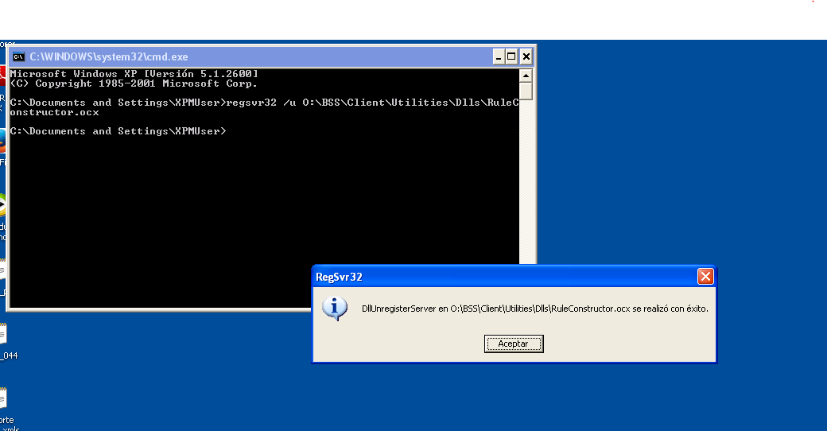
3. regsvr32 O:\BSS\Client\Utilities\Dlls\RuleConstructor.ocx
4. 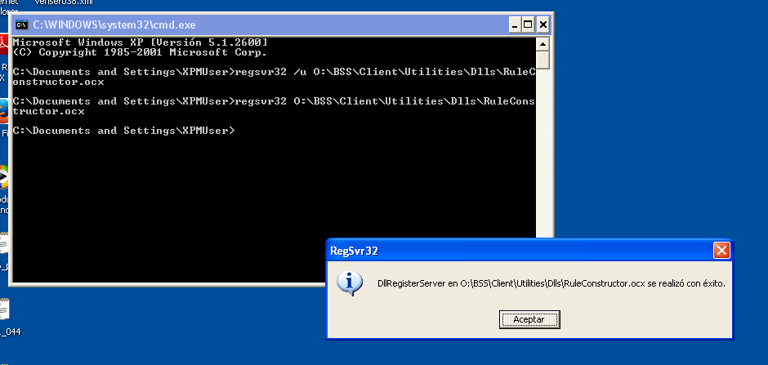regsvr32 O:\OSS\Product\GENERAL\CLIENT\FORMS\PLL\RuleConstructor.ocx
5. regsvr32 O:\BSS\Client\Utilities\Dlls\RuleConstructor.ocx